CS 255 System Design Document

UML Diagrams

UML Use Case Diagram

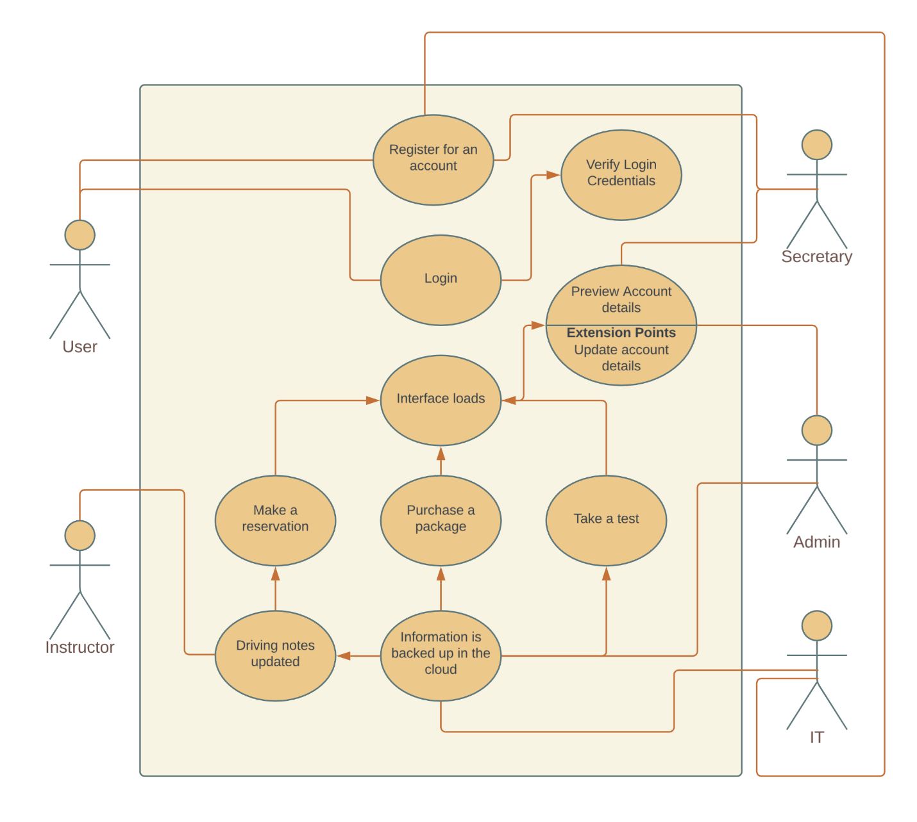

UML Activity Diagrams

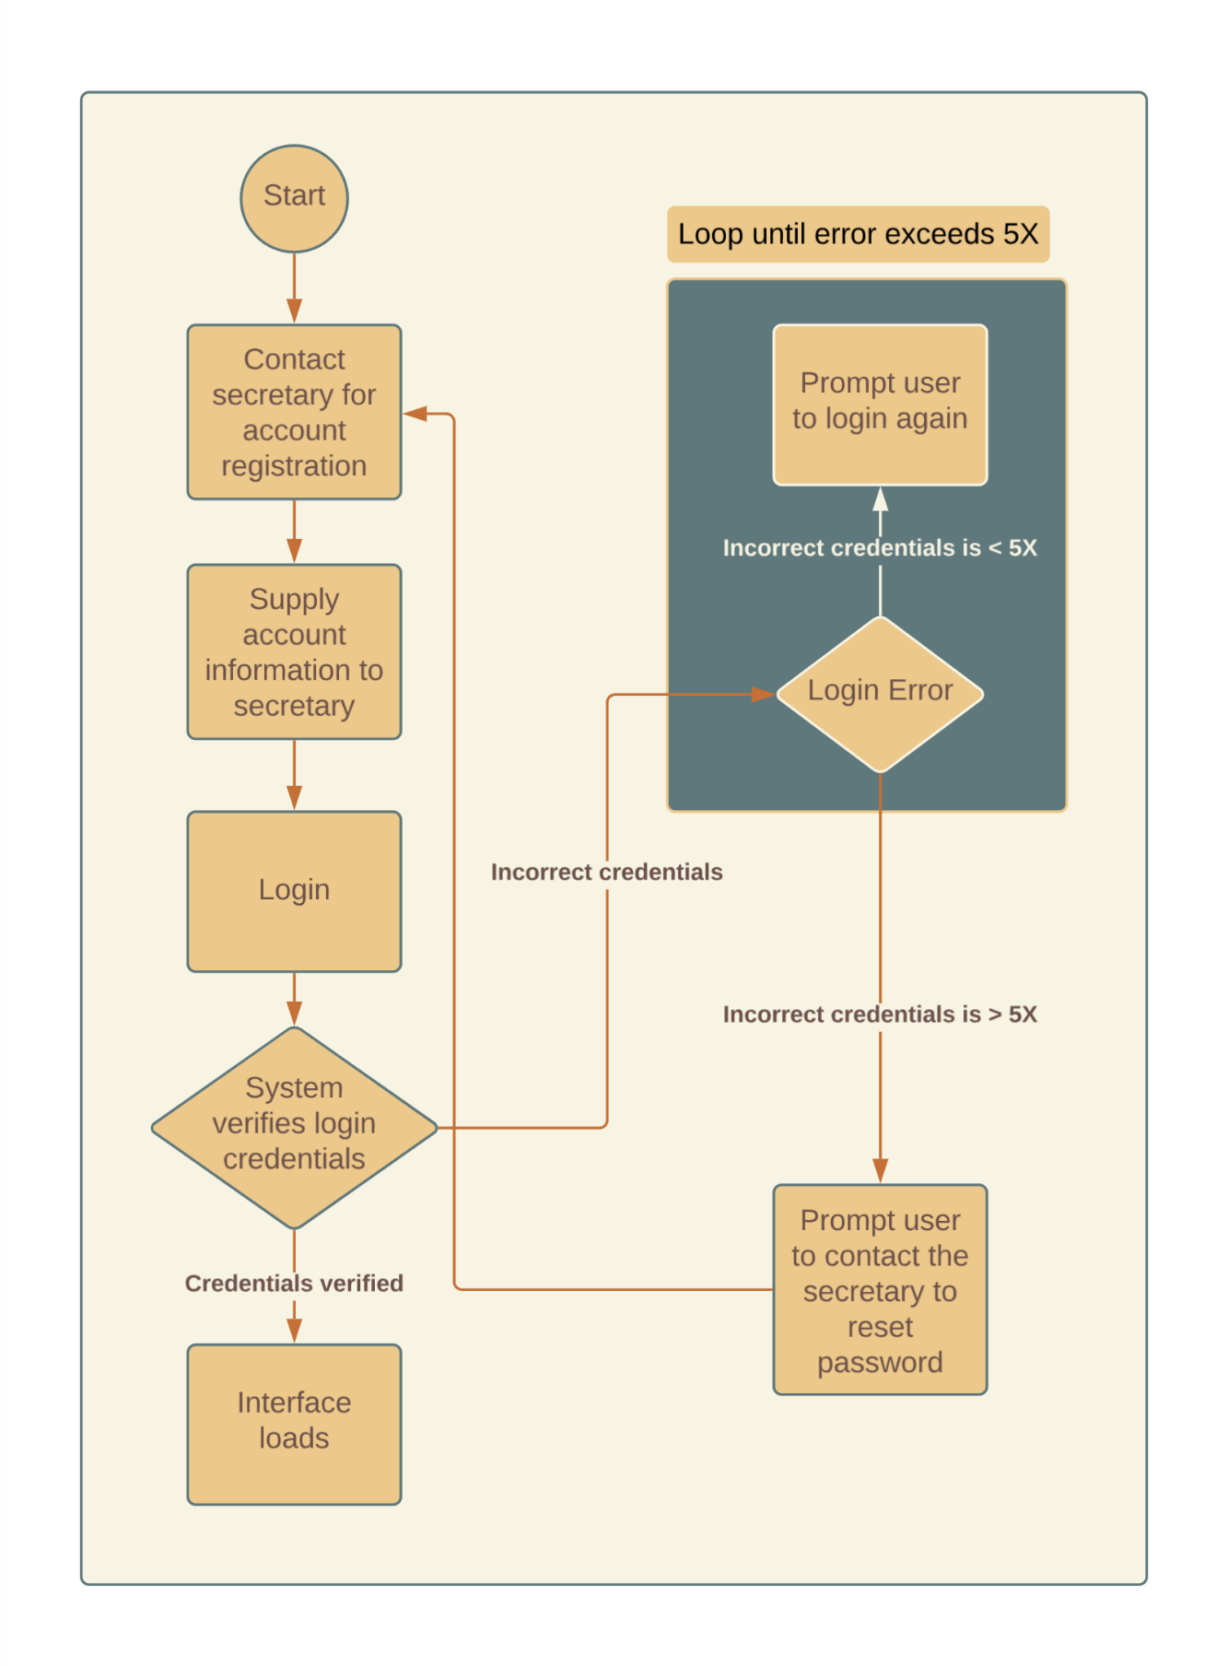

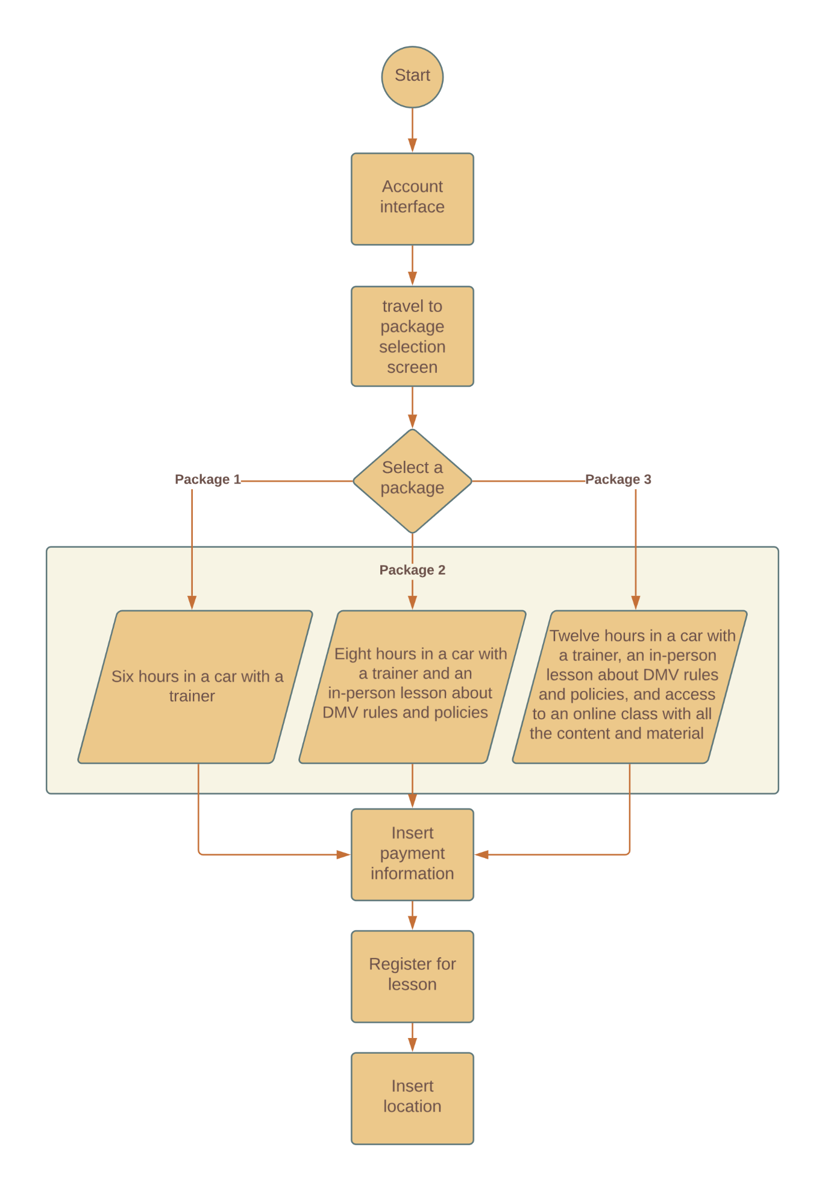

UML Sequence Diagram

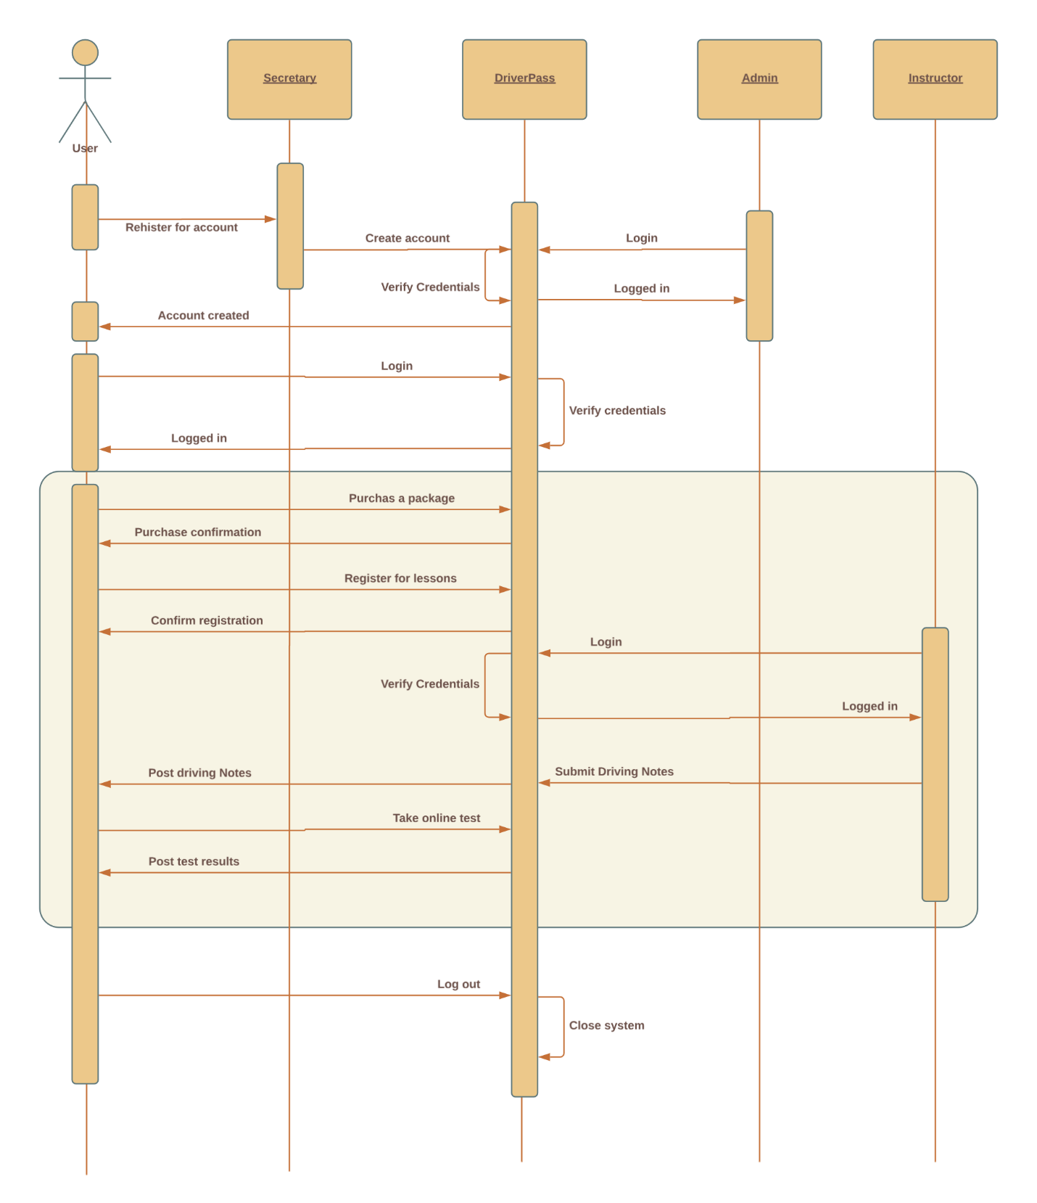

UML Class Diagram

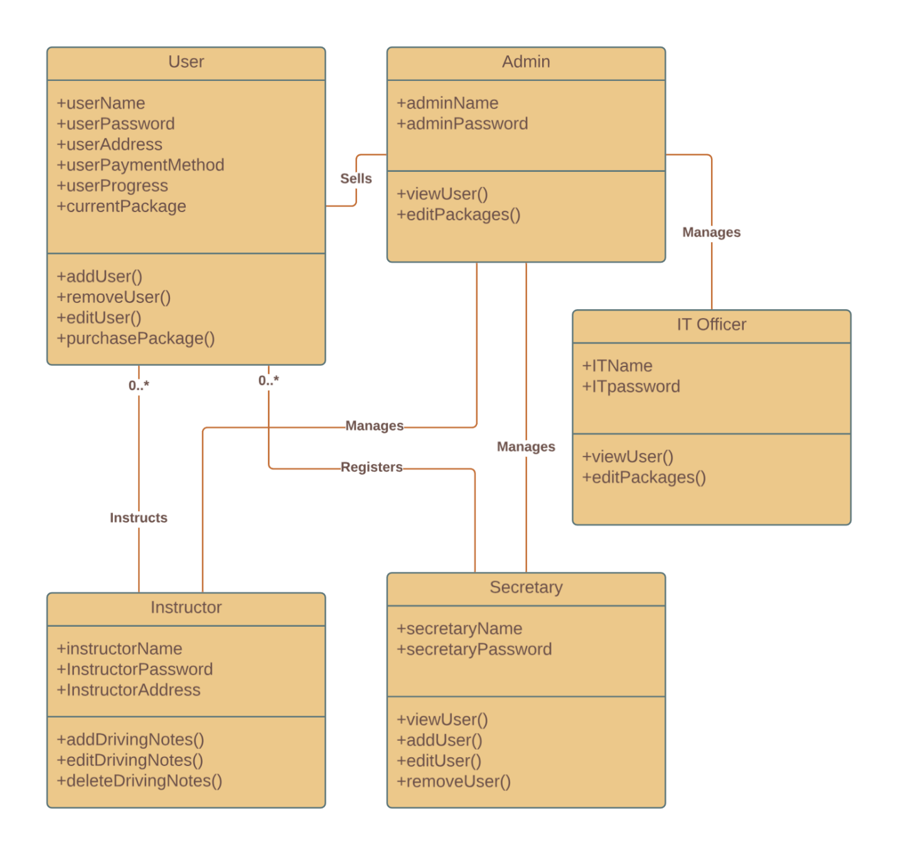

Technical Requirements

Required hardware for the DriverPass system consists of some sort of OS such as Windows, Linux, or IOS. The software would involve an online domain, a cloud-based software that suits our needs, and a way to get real-time information from the DMV regarding changes to their tests and policies. Recommended tools include the aforementioned cloud and some kind of payment service that allows funds to be transferred to the DriverPass account. Finally, the necessary infrastructure entails a roles system, online and offline access for the admin, and an account system so each customer has their account.

